HEALTHCARE DATA ANALYTICS AND DATA MINING



GROUP 1

**Doreen Accorley, Biniyam Abebe, Yash Puri, Peter Mukiibi**

**FEBRUARY 4 2025**

**Introduction**

In the ever-evolving landscape of U.S. healthcare, Medicare Advantage Plans (MA Plans) play a crucial role in providing insurance coverage to senior citizens aged 65 and older. Unlike traditional Medicare, which is directly administered by the government, MA Plans operate under a private-public partnership where commercial insurance companies manage coverage while receiving funding from Medicare. Given this unique structure, policymakers are increasingly interested in analyzing the performance, benefit generosity, and public health impact of these plans.

As part of a consulting engagement with the U.S. Congress, Brand Health Analytica Ltd. has been tasked with conducting a data-driven analysis of MA Plans across multiple states. Our study aims to:

1. Identify the most suitable insurance companies in each state for a potential private quasi-single-payer model.
2. Assess the generosity of benefit packages, with a particular focus on dental coverage.
3. Evaluate insurers' efforts in addressing the opioid crisis.

Leveraging publicly available CMS data, this analysis will provide key insights to inform congressional decision-making on the future of Medicare Advantage and broader healthcare policies.

**TOOLS USED**

* SAS Enterprise Guide
* Excel
* Tableau

Question 1

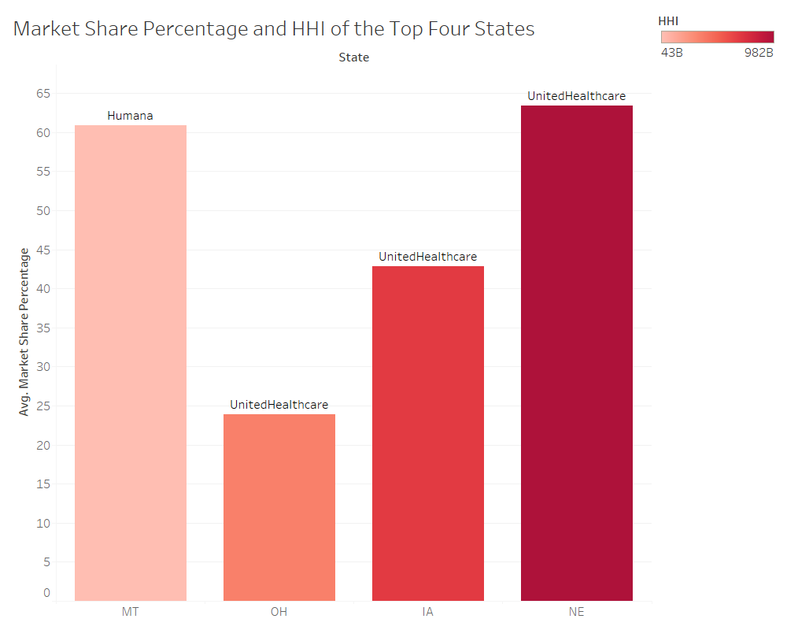

The analysis identifies the four states with the highest Herfindahl-Hirschman Index (HHI) values, indicating significant market concentration. These states are Montana (MT), Ohio (OH), Iowa (IA), and Nebraska (NE). The HHI values suggest that these states have a dominant player in their insurance markets, making them potential candidates for a private quasi-single-payer model.

* Montana (MT): Highest market share (60%) and a high HHI, indicating strong dominance by one insurance company.
* Nebraska (NE): Also highly concentrated, with the leading insurer controlling over 65% of the market.
* Iowa (IA) and Ohio (OH): Less concentrated than MT and NE but still have dominant firms with significant market shares.

**Congressional Recommendation**

If these states were to transition to a private quasi-single-payer model, the best insurance company to partner with in each state would be the one with the highest market share. Based on your data, these dominant insurers have already achieved economies of scale and control a significant portion of the market. Congress could consider delegating administrative functions to these insurers in a partnership model.

* Montana (MT) → Partner with the company controlling 60% of the market.
* Nebraska (NE) → Partner with the dominant insurer (65% share).
* Iowa (IA) → Partner with the largest insurer (45% share).
* Ohio (OH) → Partner with the dominant insurer (25-30% share, though lower than other states).

In states like Montana and Nebraska, where market concentration is highest, transitioning to a private single-payer model would be easier since a single insurer already dominates. Ohio, being more fragmented, may face more challenges in consolidating the market.

Question 2.

Top-5 Major Insurance Companies by Market Share

Based on the second visualization, the top-5 insurance companies in terms of market share across the analyzed states are:

1. Kaiser (Highest Market Share)
2. UnitedHealthcare
3. Humana
4. Blue Cross Blue Shield
5. Peoples Health

|  |  |  |  |  |  |  |
| --- | --- | --- | --- | --- | --- | --- |
| State | Insurer | Total_Enrollees | Preventive_Enrollees | Comprehensive_Enrollees | Percent_Preventive | Percent_Comprehensive |
| CA | BlueCrossBlueShield | 160248 | 153897 | 117170 | 96.04 | 73.12 |
| CA | Humana | 13 | 13 | 13 | 100.00 | 100.00 |
| CA | Kaiser | 1290663 | 858283 | 858283 | 66.50 | 66.50 |
| CA | UnitedHealthcare | 549034 | 339766 | 265325 | 61.88 | 48.33 |
| DC | BlueCrossBlueShield | 13 | 0 | 0 | 0.00 | 0.00 |
| DC | Kaiser | 7063 | 4730 | 4730 | 66.97 | 66.97 |
| DC | UnitedHealthcare | 19555 | 9302 | 9302 | 47.57 | 47.57 |
| IA | Humana | 22666 | 22666 | 22666 | 100.00 | 100.00 |
| IA | UnitedHealthcare | 45734 | 29654 | 27743 | 64.84 | 60.66 |
| LA | BlueCrossBlueShield | 9262 | 1881 | 1881 | 20.31 | 20.31 |
| LA | Humana | 279425 | 274443 | 274443 | 98.22 | 98.22 |
| LA | Peoples Health | 280941 | 278759 | 278759 | 99.22 | 99.22 |
| LA | UnitedHealthcare | 28467 | 3894 | 3894 | 13.68 | 13.68 |
| MD | BlueCrossBlueShield | 37 | 0 | 0 | 0.00 | 0.00 |
| MD | Kaiser | 72936 | 57432 | 57432 | 78.74 | 78.74 |
| MD | UnitedHealthcare | 52970 | 27234 | 17262 | 51.41 | 32.59 |
| MT | BlueCrossBlueShield | 16231 | 14419 | 14419 | 88.84 | 88.84 |
| MT | UnitedHealthcare | 4271 | 2095 | 2095 | 49.05 | 49.05 |
| NE | BlueCrossBlueShield | 13 | 0 | 0 | 0.00 | 0.00 |
| NE | Humana | 12564 | 12550 | 12550 | 99.89 | 99.89 |
| NE | UnitedHealthcare | 65997 | 59389 | 58309 | 89.99 | 88.35 |
| OH | UnitedHealthcare | 93441 | 18271 | 18271 | 19.55 | 19.55 |

Question number 3.

|  |  |  |  |
| --- | --- | --- | --- |
| State | MajorInsuranceOrgName | Weighted_UOP_Rate | Rank |
| CA | Kaiser | 24.03 | 1 |
| CA | IEHP DualChoice | 19.84 | 2 |
| CA | Humana | 12.91998 | 3 |
| CA | Aetna Health Inc. | 12.06251 | 4 |
| CA | BlueCrossBlueShield | 11.70495 | 5 |
| CA | UnitedHealthcare | 11.64093 | 6 |
| CA | Brand New Day | 11.23 | 7 |
| CA | SCAN Health Plan | 11 | 8 |
| CA | Alignment Health Plan | 8.974457 | 9 |
| CA | Central Health Medicare Plan | 6.59 | 10 |
| DC | Kaiser | 14.24 | 1 |
| DC | Aetna Health Inc. | 12.80702 | 2 |
| DC | UnitedHealthcare | 12.61154 | 3 |
| DC | BlueCrossBlueShield | 11.45729 | 4 |
| DC | Humana | 11.33 | 5 |
| IA | UnitedHealthcare | 13.09875 | 1 |
| IA | Humana | 11.54768 | 2 |
| IA | MediGold | 11.31197 | 3 |
| IA | BlueCrossBlueShield | 10.63 | 4 |
| IA | Aetna Health Inc. | 9.293054 | 5 |
| IA | HealthPartners UnityPoint Health | 9.19 | 6 |
| IA | Health Alliance Medicare | 2.666026 | 7 |
| LA | UnitedHealthcare | 13.62465 | 1 |
| LA | Aetna Health Inc. | 12.30194 | 2 |
| LA | Peoples Health | 9.424176 | 3 |
| LA | Humana | 9.145405 | 4 |
| LA | BlueCrossBlueShield | 8.008452 | 5 |
| MD | UnitedHealthcare | 15.18827 | 1 |
| MD | Kaiser | 14.24 | 2 |
| MD | Aetna Health Inc. | 12.61605 | 3 |
| MD | Humana | 11.79723 | 4 |
| MD | BlueCrossBlueShield | 11.73054 | 5 |
| MT | PacificSource Medicare | 14.0321 | 1 |
| MT | BlueCrossBlueShield | 12.73785 | 2 |
| MT | Aetna Health Inc. | 12.49454 | 3 |
| MT | Humana | 12.42628 | 4 |
| MT | UnitedHealthcare | 10.90516 | 5 |
| NE | BlueCrossBlueShield | 12.95941 | 1 |
| NE | Aetna Health Inc. | 12.63973 | 2 |
| NE | Humana | 11.72774 | 3 |
| NE | UnitedHealthcare | 11.57254 | 4 |
| OH | Devoted Health | 17.52801 | 1 |
| OH | BlueCrossBlueShield | 14.02557 | 2 |
| OH | UnitedHealthcare | 13.8695 | 3 |
| OH | SummaCare Medicare Advantage Plans | 13.69 | 4 |
| OH | Medical Mutual of Ohio | 13.61124 | 5 |
| OH | Aetna Health Inc. | 13.40743 | 6 |
| OH | Humana | 12.96034 | 7 |
| OH | PrimeTime Health Plan | 12.05 | 8 |
| OH | MediGold | 9.765637 | 9 |
| OH | The Health Plan | 7.885122 | 10 |

The data represents the top 10 insurers by their Weighted UOP Rate for each state, ranked accordingly. In California (CA), Kaiser holds the top position with a significant lead at a Weighted UOP Rate of 24.03, followed by IEHP Dual Choice at 19.84, and Humana at 12.92. Other major players like Aetna Health Inc., Blue Cross Blue Shield, and UnitedHealthcare also occupy spots in the top ten. Moving to District of Columbia (DC), Kaiser takes the first position again, with Aetna Health Inc. and UnitedHealthcare following closely behind. For Iowa (IA), UnitedHealthcare leads with a rate of 13.10, followed by Humana at 11.55. In Louisiana (LA), UnitedHealthcare ranks first with a rate of 13.62, and Aetna Health Inc. is in second place. Maryland (MD) sees UnitedHealthcare as the leading insurer, followed by Kaiser. In Montana (MT), Pacific Source Medicare is the top performer, with Blue Cross Blue Shield and Aetna Health Inc. ranking second and third respectively. Nebraska (NE) shows Blue Cross Blue Shield taking the first rank, followed by Aetna Health Inc. Ohio (OH) exhibits a more varied range, with Devoted Health ranking first, followed by Blue Cross Blue Shield, and UnitedHealthcare in third place.

This ranking and performance data reflect the insurers' market standing in terms of their UOP rate, which is a key performance metric in evaluating insurer quality and beneficiary satisfaction in various states.

**SQL CODES USING SAS**

**Question 1**

**CASE WHEN pbp_b16a_bendesc_yn = 1 THEN Enrollment ELSE 0 END**

**PROC** **SQL**;

   CREATE TABLE WORK.QUERY_FOR_CPSC_ENROLLMENT_I_0000 AS

   SELECT t1.'Contract Number'n,

          t1.'Plan ID'n,

          t1.'SSA State County Code'n,

          t1.'FIPS State County Code'n,

          t1.State,

          t1.County,

          t1.Enrollment

      FROM WORK.QUERY_FOR_CPSC_ENROLLMENT_INFO_2 t1

      WHERE t1.State = 'CA' OR t1.State = 'DC' OR t1.State = 'IA' OR t1.State = 'LA' OR t1.State = 'MD' OR t1.State =

           'MT' OR t1.State = 'NE' OR t1.State = 'OH' OR t1.State = 'WA';

**QUIT**;

**PROC** **SQL**;

   CREATE TABLE WORK.QUERY_FOR_CPSC_ENROLLMENT_INFO_2 AS

   SELECT t1.'Contract Number'n,

          t1.'Plan ID'n,

          t1.'SSA State County Code'n,

          t1.'FIPS State County Code'n,

          t1.State,

          t1.County,

          t1.Enrollment

      FROM WORK.CPSC_ENROLLMENT_INFO_2024_01 t1

      WHERE t1.'Contract Number'n CONTAINS 'E' OR t1.'Contract Number'n CONTAINS 'H' OR t1.'Contract Number'n CONTAINS

           'R';

**QUIT**;

**PROC** **SQL**;

   CREATE TABLE WORK.QUERY_FOR_CPSC_ENROLLMENT_I AS

   SELECT t1.'Contract Number'n,

          t1.'Plan ID'n,

          t1.'SSA State County Code'n,

          t1.'FIPS State County Code'n,

          t1.State,

          t1.County,

          t1.Enrollment

      FROM WORK.QUERY_FOR_CPSC_ENROLLMENT_I_0000 t1

      WHERE t1.Enrollment NOT CONTAINS '*';

**QUIT**;

**PROC** **SQL**;

   CREATE TABLE WORK.QUERY_FOR_CPSC_ENROLLMENT_I_0001 AS

   SELECT t1.'Contract Number'n,

          t1.'Plan ID'n,

          t1.'SSA State County Code'n,

          t1.'FIPS State County Code'n,

          t1.State,

          t1.County,

          t1.Enrollment,

          t2.'Organization Marketing Name'n

      FROM WORK.QUERY_FOR_CPSC_ENROLLMENT_I t1

           LEFT JOIN WORK.MONTHLY_REPORT_BY_PLAN_2024_0002 t2 ON (t1.'Contract Number'n = t2.'Contract Number'n) AND

          (t1.'Plan ID'n = t2.'Plan ID'n);

**QUIT**;

**PROC** **SQL**;

   CREATE TABLE WORK.QUERY_FOR_CPSC_ENROLLMENT_I_0002 AS

   SELECT t1.'Contract Number'n,

          t1.'Plan ID'n,

          t1.'SSA State County Code'n,

          t1.'FIPS State County Code'n,

          t1.State,

          t1.County,

          t1.Enrollment,

          t1.'Organization Marketing Name'n,

          t2.MajorInsuranceOrgName

      FROM WORK.QUERY_FOR_CPSC_ENROLLMENT_I_0001 t1

           INNER JOIN WORK.MAJORINSURANCEORGS t2 ON (t1.'Organization Marketing Name'n = t2.

          'Organization Marketing Name'n);

**QUIT**;

**PROC** **SORT**

DATA=WORK.QUERY_FOR_CPSC_ENROLLMENT_I_0002(KEEP=Enrollment MajorInsuranceOrgName State)

OUT=WORK.SORTTempTableSorted

;

BY State;

**RUN**;

/* -------------------------------------------------------------------

   Run the Means Procedure

   ------------------------------------------------------------------- */

TITLE;

TITLE1 "Summary Statistics";

TITLE2 "Results";

FOOTNOTE;

FOOTNOTE1 "Generated by SAS (&_SASSERVERNAME, &SYSSCPL) on %TRIM(%QSYSFUNC(DATE(), NLDATE20.)) at %TRIM(%QSYSFUNC(TIME(), NLTIMAP25.))";

**PROC** **MEANS** DATA=WORK.SORTTempTableSorted

FW=**12**

PRINTALLTYPES

CHARTYPE

NWAY

SUM NONOBS ;

VAR Enrollment;

CLASS MajorInsuranceOrgName / ORDER=UNFORMATTED ASCENDING;

BY State;

OUTPUT OUT=WORK.MEANSummaryStats(LABEL="Summary Statistics for WORK.QUERY_FOR_CPSC_ENROLLMENT_I_0002")

SUM()=

/ AUTONAME AUTOLABEL  WAYS INHERIT

;

**RUN**;

/* -------------------------------------------------------------------

   End of task code

   ------------------------------------------------------------------- */

**RUN**; **QUIT**;

%***_eg_conditional_dropds***(WORK.SORTTempTableSorted);

TITLE; FOOTNOTE;

**Question 2**

**PROC** **SQL**;

CREATE TABLE WORK.QUERY_FOR_HEDIS AS

SELECT t1.CMSContractNumber,

t1.MeasureCode,

t1.IndicatorKey,

t1.Rate,

t1.Denominator,

t1.MemberCount,

t1.Numerator

FROM WORK.HEDIS2024 t1

WHERE t1.IndicatorKey = '202529_10';

**QUIT**;

**PROC** **SQL**;

CREATE TABLE WORK.'QUERY_FOR_MRGED AND CLEAN FOR MA'n AS

SELECT t1.'Contract Number'n,

t1.'Plan ID'n,

t1.State,

t1.Enrollment,

t1.MajorInsuranceOrgName,

t2.MeasureCode,

t2.IndicatorKey,

t2.Rate,

t2.Denominator,

t2.MemberCount,

t2.Numerator

FROM WORK.'MRGED AND CLEAN FOR MAJOR SHARE'n t1

INNER JOIN WORK.QUERY_FOR_HEDIS t2 ON (t1.'Contract Number'n = t2.CMSContractNumber);

**QUIT**;

**Question 3**

**PROC** **SQL**;

CREATE TABLE WORK.'QUERY_FOR_MRGED AND CLEAN FOR MA'n AS

SELECT t1.'Contract Number'n,

t1.'Plan ID'n,

t1.State,

t1.Enrollment,

t1.MajorInsuranceOrgName,

t2.MeasureCode,

t2.IndicatorKey,

t2.Rate,

t2.Denominator,

t2.MemberCount,

t2.Numerator

FROM WORK.'MRGED AND CLEAN FOR MAJOR SHARE'n t1

INNER JOIN WORK.QUERY_FOR_HEDIS t2 ON (t1.'Contract Number'n = t2.CMSContractNumber);

**QUIT**;

**PROC** **SQL**;

CREATE TABLE WORK.CONTRACT_RATES AS

SELECT t1.'Contract Number'n,

t1.State,

t1.Enrollment,

t1.MajorInsuranceOrgName,

t2.MeasureCode,

t2.IndicatorKey,

t2.Rate

FROM WORK.'MRGED AND CLEAN FOR MAJOR SHARE'n t1

INNER JOIN WORK.QUERY_FOR_HEDIS t2

ON t1.'Contract Number'n = t2.CMSContractNumber

WHERE t2.MeasureCode = 'UOP'

AND t2.IndicatorKey = '202529_10'

AND t2.Rate IS NOT NULL;

**QUIT**;

Change rate to numeric than character before proceding

**PROC** **SQL**;

CREATE TABLE WORK.TOP10_INSURERS AS

SELECT State, MajorInsuranceOrgName, SUM(Enrollment) AS TotalEnrollment

FROM WORK.CONTRACT_RATES

GROUP BY State, MajorInsuranceOrgName

ORDER BY State, TotalEnrollment DESC;

**QUIT**;

**DATA** WORK.TOP10_INSURERS;

SET WORK.TOP10_INSURERS;

BY State;

IF FIRST.State THEN Rank = **0**; /* Reset rank for each state */

Rank + **1**;

IF Rank <= **10**; /* Keep only top 10 insurers */

**RUN**;

**PROC** **SQL**;

CREATE TABLE WORK.WEIGHTED_AVG AS

SELECT a.State,

a.MajorInsuranceOrgName,

SUM(a.Enrollment * a.Rate) / SUM(a.Enrollment) AS Weighted_UOP_Rate

FROM WORK.CONTRACT_RATES a

INNER JOIN WORK.TOP10_INSURERS b

ON a.State = b.State AND a.MajorInsuranceOrgName = b.MajorInsuranceOrgName

GROUP BY a.State, a.MajorInsuranceOrgName;

**QUIT**;

**PROC** **SORT** DATA=WORK.WEIGHTED_AVG;

BY State DESCENDING Weighted_UOP_Rate;

**RUN**;

**DATA** WORK.RANKED_INSURERS;

SET WORK.WEIGHTED_AVG;

BY State;

IF FIRST.State THEN Rank = **1**; /* Start rank at 1 for each state */

ELSE Rank + **1**; /* Increment rank for subsequent records within the same state */

IF Weighted_UOP_Rate = **.** THEN DELETE; /* Remove rows with missing Weighted_UOP_Rate */

**RUN**;